

**AD HOC TRAINING ENTRY**

To enter Ad Hoc training, go to **CREW TRAINING -> ADHOC TRAINING -> ENTER ADHOC TRAINING**

**1**

This is what the screen will look like. You can choose from the list to the left if you are entering training for a PFF or if you are doing crew based training, simply click .

When you choose from the items on the left:

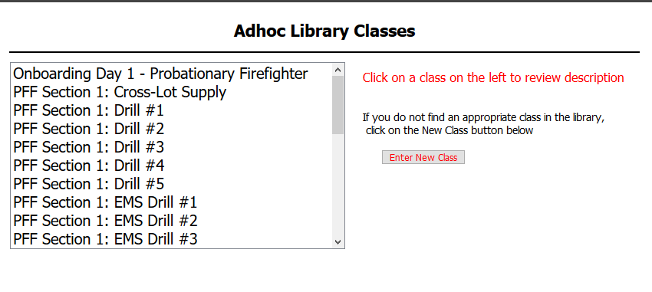

**2**

You will get this is the screen that shows a short description. Choose what is appropriate and follow along.

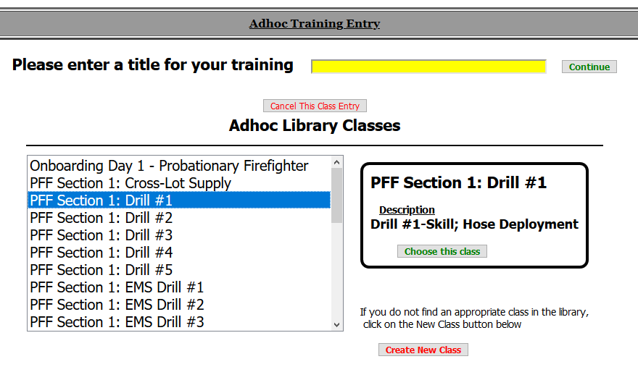

Should you want to enter your own AD HOC training, instead of clicking on the list to the left,

**1**

click . Here you will add a title. Please keep it brief and as exact as possible.

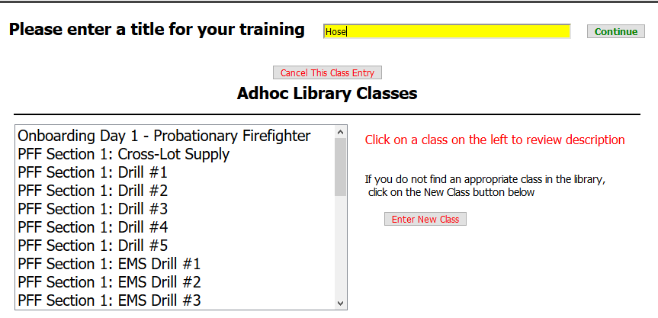

Disregard this

section

**2**



Once you click , you come to this screen.

Be sure to enter accurate hours, add the appropriate lesson(s) and don’t forget to add the personnel who attended the training. Then click

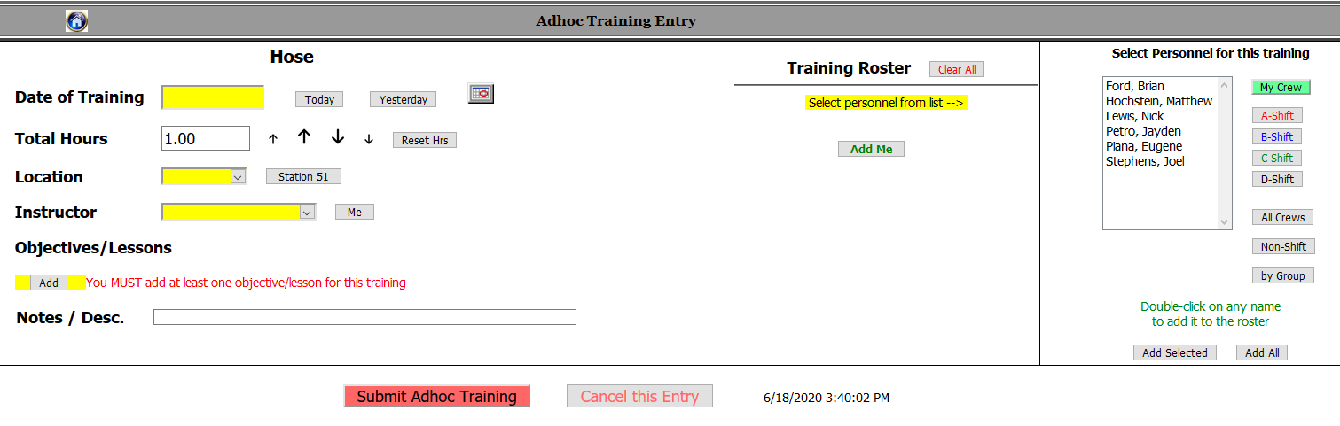

**Ad Hoc Made Easy**

I have added Ad Hoc lessons to the library. Under Objectives/Lessons, click ADD



You will get this screen:

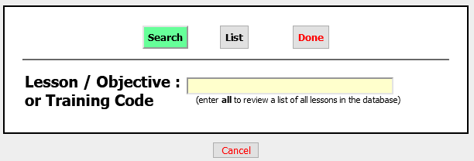

Chose List

Then you will get this screen:

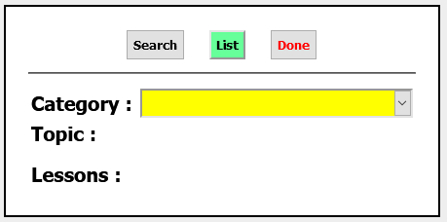

For Category, scroll until you see Ad Hoc General

For Topic, choose Ad Hoc

Then you will see the general Ad Hoc Lessons:

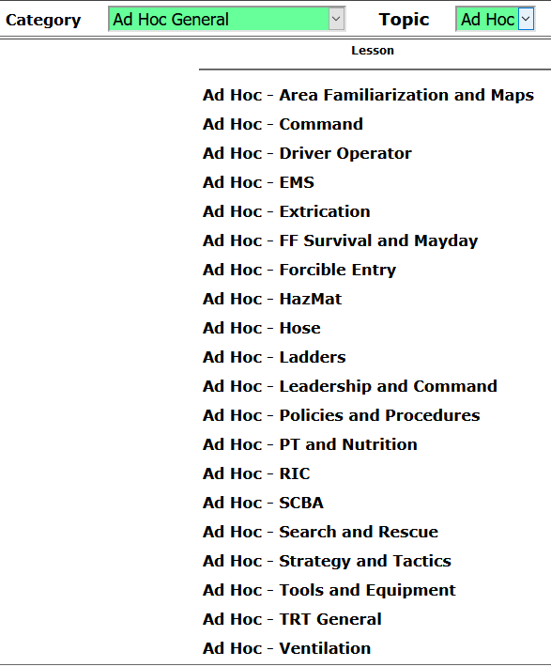

You can add whatever notes you’d like to give more detailed information. Don’t forget the other pertinent information.

I hope this helps!

Any questions or suggestions, please contact Danielle at dmagistrale@nkctc.org.